________________ School Presents:

Homework
A Parent’s Guide to Helping Out
Without Freaking Out!

Date:
Time:
Location:

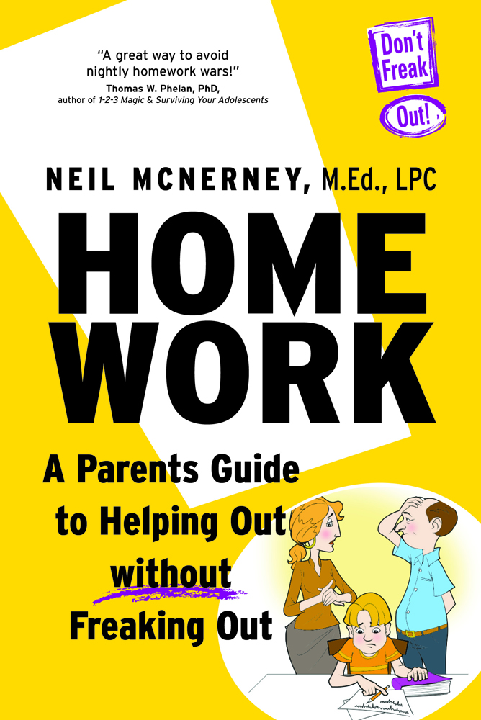
We are excited to have Neil McNerney speak on the topic of homework. Neil, a licensed counselor and parenting expert, will show us ways to help our child do better in school without arguments, yelling, or guilt.
In his 25 years working with school-age children and their parents, Neil has developed a simple approach that will increase achievement and decrease aggravation.

Neil will share ideas from his book: Homework – A Parent’s Guide to Helping Out Without Freaking Out!

Based on proven theory and recent data on the brain, this seminar will help all parents be the best leaders they can be for their children.

- Share three ways to increase motivation without messing it up!

- Discuss three ideas on how to give advice so it will be followed!

- Help you decide when to reward and when to punish when it comes to homework and schoolwork.

Parents Have Said…
“Neil’s sense of humor, his down-to-earth nature, and especially his message, left me feeling energized & ready to try something new.”

