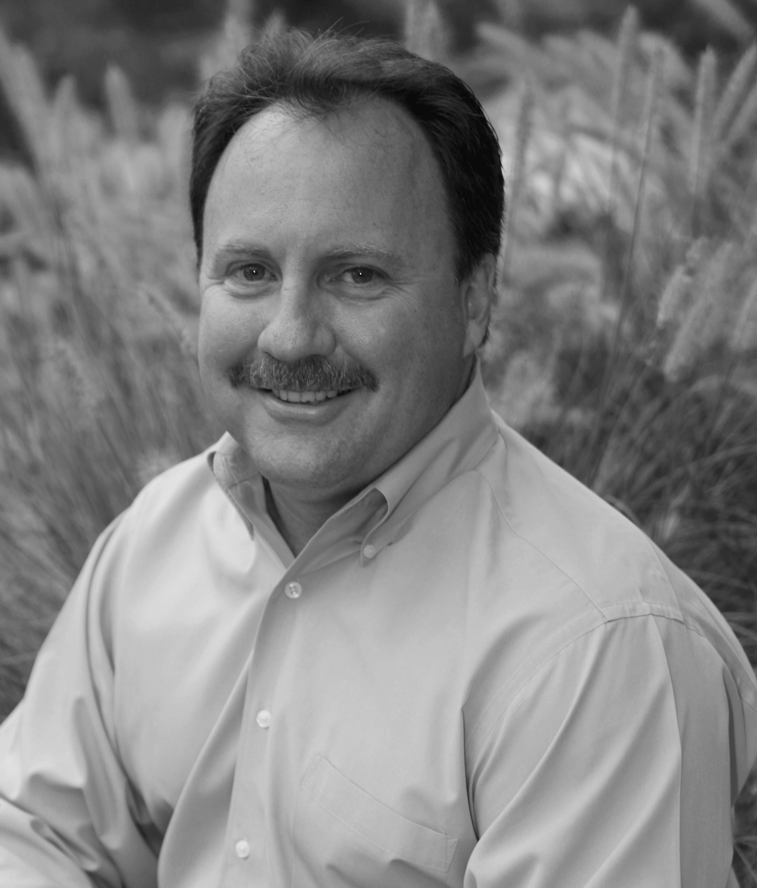

Neil McNerney, a

Licensed Professional

Counselor and Family

Therapist, will show you

specific skills to help

restore calm, reclaim

respect, and regain love

and fun in your family.

In addition to being a

licensed counselor and

serving on the faculty of the Virginia Tech Graduate School, Neil is a certified parent coach. His background in biology brings a great combination to learning about the teen brain.

More and more, traditional parenting techniques don’t work with children these days. Kids are smarter, more clever, and feel more entitled than ever before. No amount of "in my day" discussions will change that kids "these days" are different, and we need new tools to keep ahead of them.

Neil McNerney, LPC

703-352-9002

neil@neilmcnerney.com

www.neilmcnerney.com

School:

Date:

Time:

Location

Intriguing New Brain Research....

…is verifying what every parent of a teenager already figured out: The teenage years look a lot like temporary insanity. The more we learn about what is going on in the teenage brain, the more our teens actions, crazy as they seem, begin to make sense.

**“What Were You Thinking?”**

That’s the thing…they weren’t thinking. At least in the way we understand “thinking.”

Neil McNerney, a licensed professional counselor and parenting expert, will share with you an easy-to-understand model of what’s going on inside your teen’s head. Most importantly, he will give you specific ways to deal with your teen without losing your own sanity!

***Parents Have Said:***

*“Neil is a great instructor! His personal stories made the program real. He truly cares about giving parents tools that work.”*

*“I didn’t want to come at first, since I thought this would be a lecture that I would leave feeling worse. But Neil’s sense of humor, his down-to-earth nature, and especially his message, left me feeling energized and ready to try something new.”*

The Teenage Brain

…Temporary Insanity?

Services:

* Individual and Family Counseling
* Parenting Consultations
* In-Home behavior consultations
* Keynotes, Trainings, and Workshops

.

**Parents Have Said:**

“Neil is a great instructor! His personal stories made the program real. He truly cares about giving parents tools that work.”