“Just Calm Down!”

**Dealing with Over-Reactive Parent**

Topics

• **Effects of anxious parents**

**• Don’t take it personally**

**• Stay calm**

* **Shoulder-to-shoulder**
* **Set boundaries**
  + **Email**
  + **Phone**
  + **Hallway**
  + **Conferences**
  + **Treatment Planning**

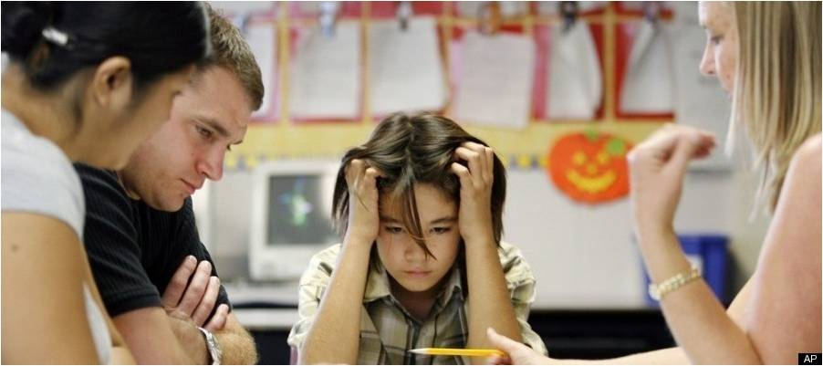

The Effects of Anxious Parents

“Remember:

you and the parent want the same thing.”

The level of “helicopter parents” has dramatically increased over the past ten years, causing difficulties for parents, teachers, and especially students/children.

Media tend to send two conflicting messages when it comes to parenting:

#1 Parental involvement is crucial to your child’s success.

#2 Children need to complete their own work

Unfortunately, the parents that should hear the message about backing off tend to only hear the message about parent involvement being crucial.

Although it is easy to stereotype helicopter parents, stereotypes don’t help us deal better with this phenomenon. What we need are specific techniques to help reduce the reactivity of over-anxious parents.



Don’t Take It Personally

This is much harder said than done. You are a dedicated counselor who has committed your career to helping clients/students.

1. It’s Not About You

2. Stay Calm

**Neil McNerney, M.Ed., LPC – neil@neilmcnerney.com – www.neilmcnerney.com**

**Emily Goodman Scott, MA.Ed., NCC – egscott@vt.edu**

**Jennifer L. Scott, MA.Ed., NCC - jennyscott@me.com**

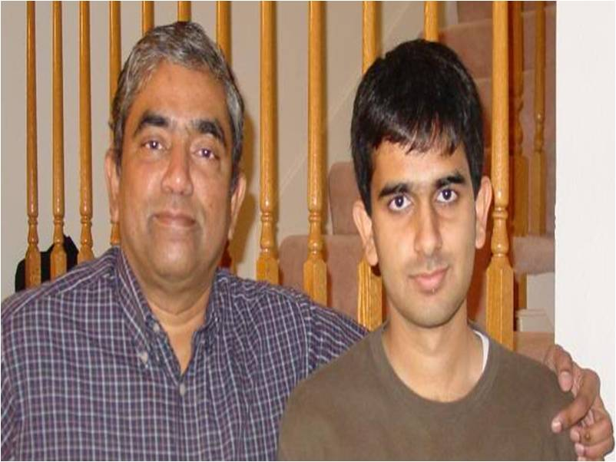

Shoulder-to-Shoulder

1. Awareness – How am I feeling?

2. Awareness – How is the parent feeling?

3. Communicate Empathy

**Toe-to-toe signifies confrontation and that there will be a winner and a loser. Shoulder-to-shoulder signifies cooperation and a focus on the goal: student/client success.**

Boundaries

1. Emails

2. Phone Calls

3. Hallway Interruptions

4. Conferences

5. Treatment Plans



You can only set boundaries for one person:

Yourself

You are not responsible

for

your students/clients. You are responsible

to

them

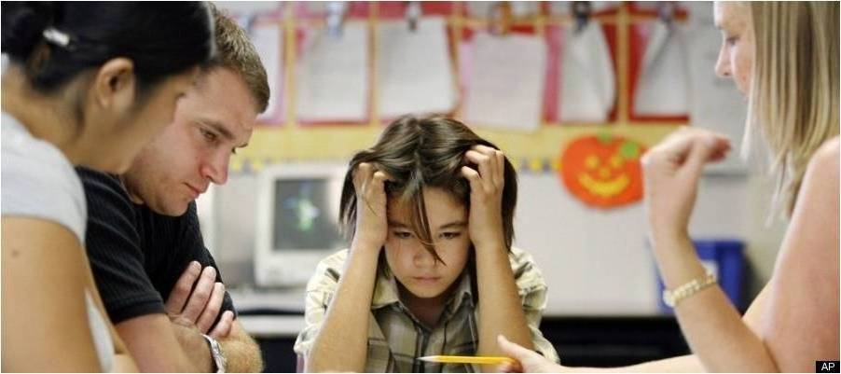

**Neil McNerney, M.Ed., LPC – neil@neilmcnerney.com – www.neilmcnerney.com**

**Emily Goodman Scott, MA.Ed., NCC –** [**egscott@vt.edu**](mailto:emilygoodmanscott@gmail.com)

**Jennifer L. Scott, MA.Ed., NCC - jennyscott@me.com**